Docker Basics:

Contents

What and why Docker? 1

Problems beofore Docker 2

Docker Architecture 3

Docker Workflow 4

Docker installation on Windows 4

How to push and pull Docker Image from Docker Hub? 6

# What and why Docker?

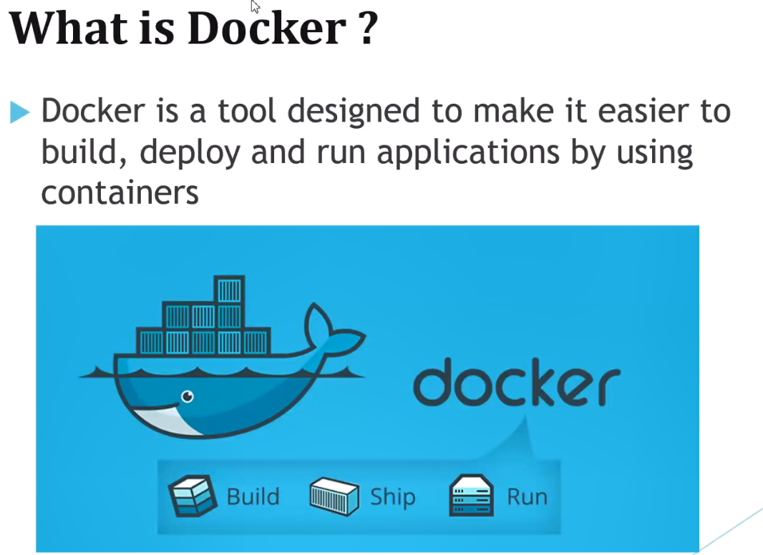

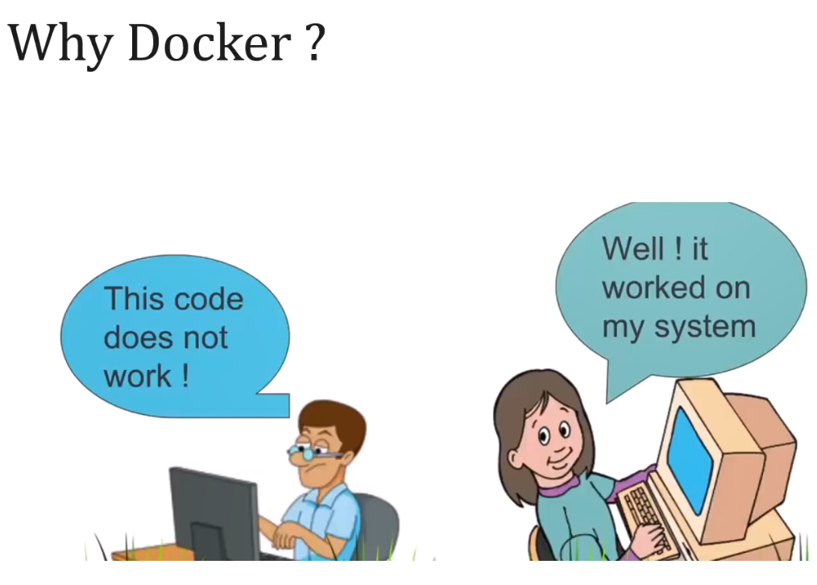

# Problems beofore Docker

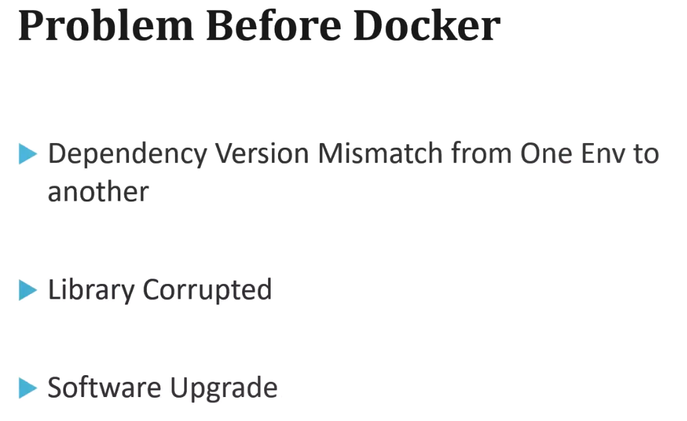

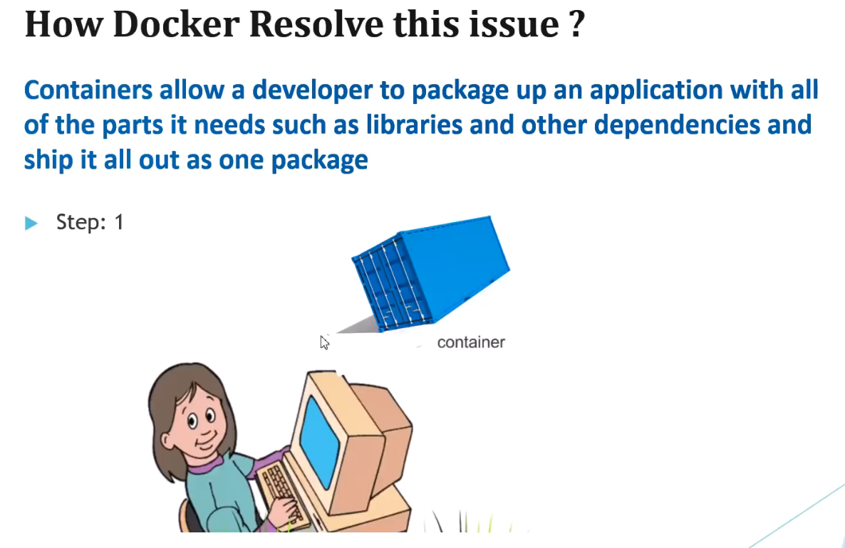



This is the Docker engine.

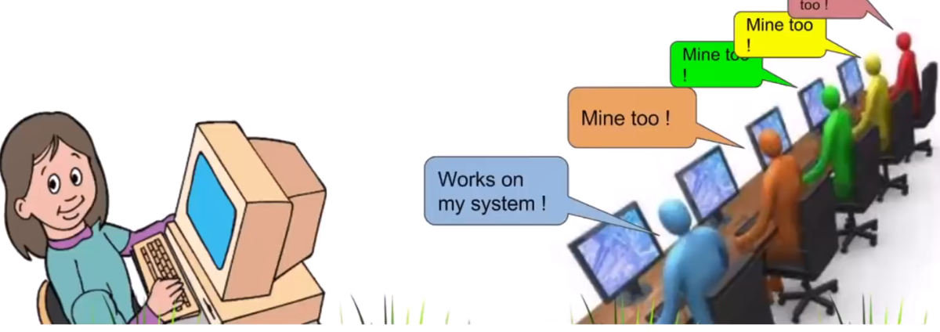

# Docker Architecture

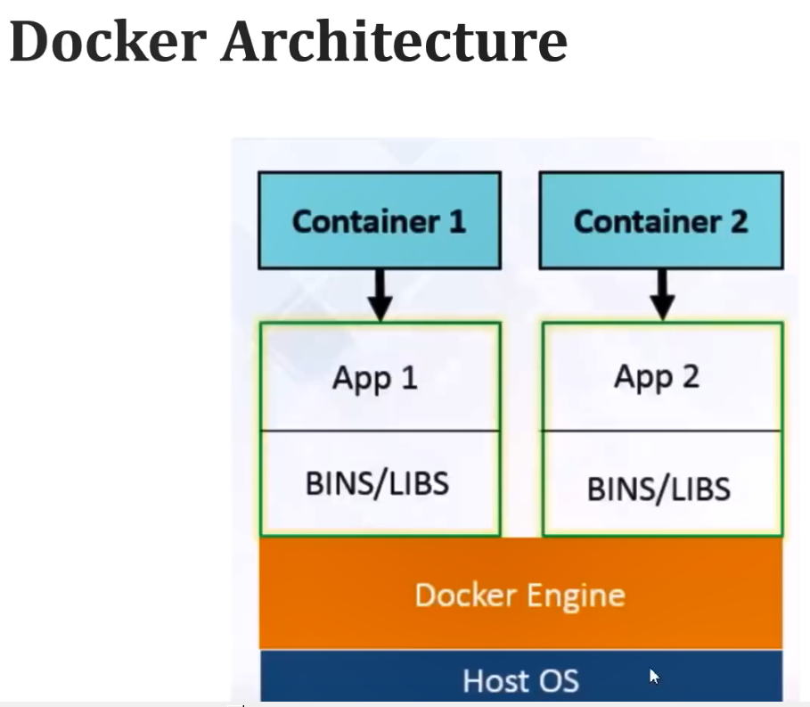

The advantage of Docker:

Here it occupies memory on the Host OS instead of Guest OS.

In Host OS, it occupies very less memory as compared to normal virtual machine.

# Docker Workflow

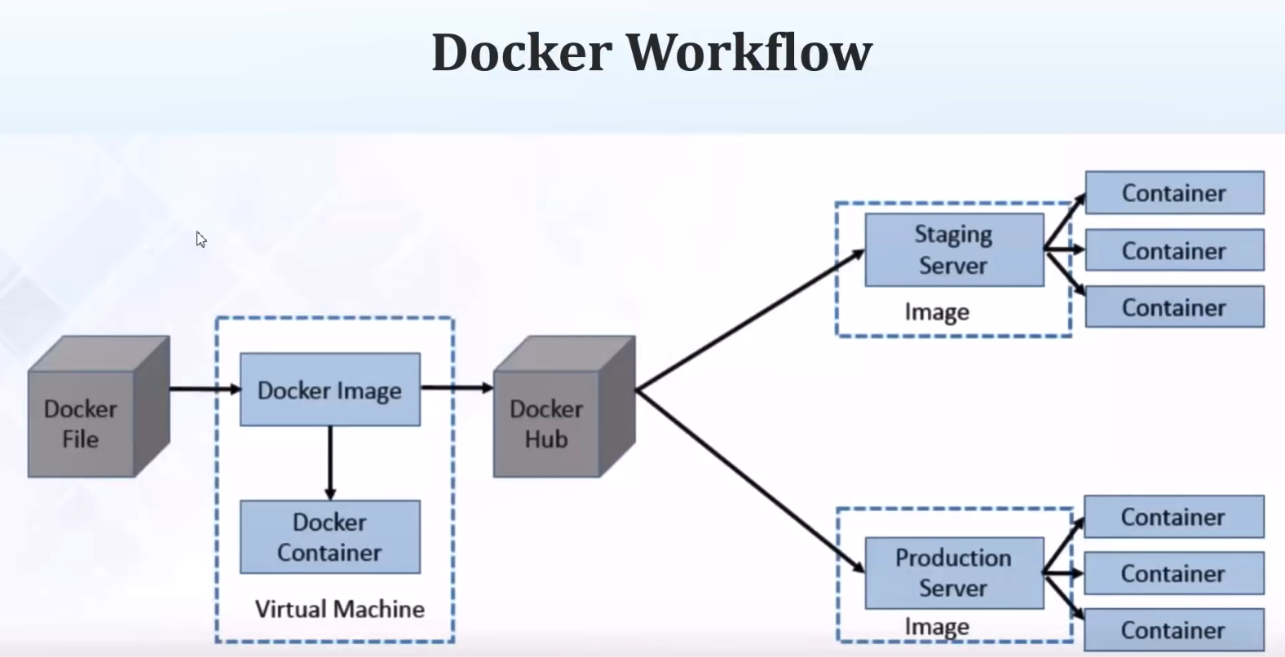

As developer we write the “Docker File”.

Then with the help of Docker command we create a “Docker Image”. Docker Image is the skeleton of our application.

“Docker Container” is simply the running instance of the “Docker Image”.

We need to keep our “Docker Image” in “Docker Hub”. It’s kind of repository like Maven central repository. Similarly, from Docker Hub we can pull the Docker Image.

# Docker installation on Windows

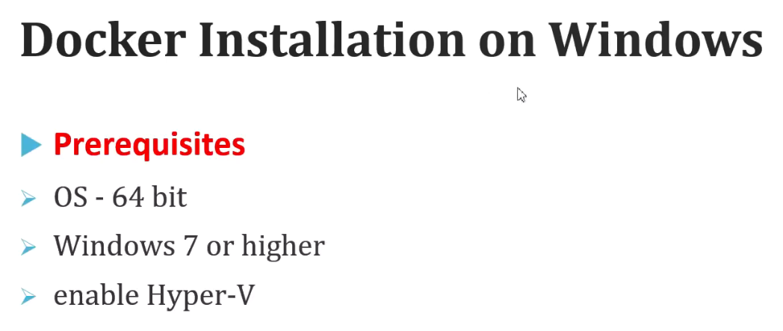

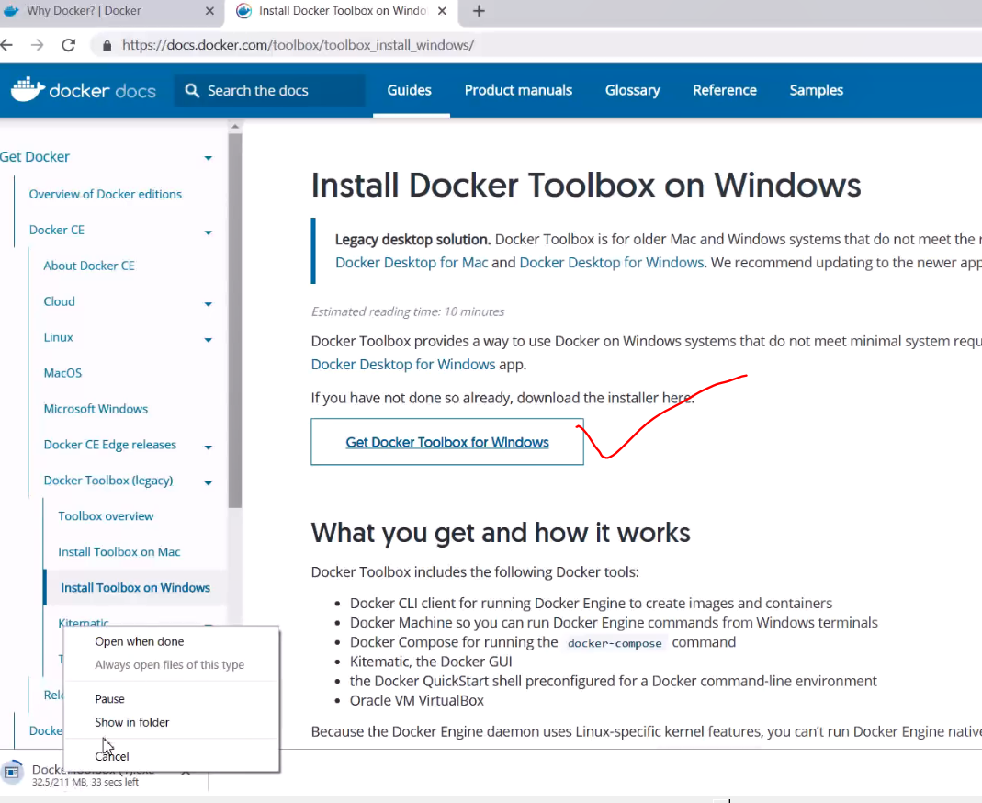

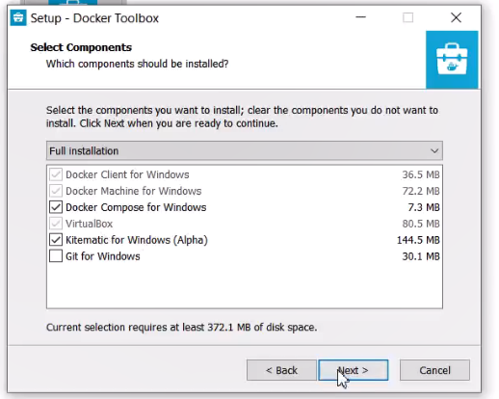

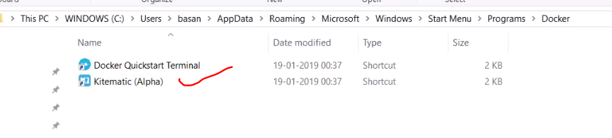

This is the GUI page for Docker.

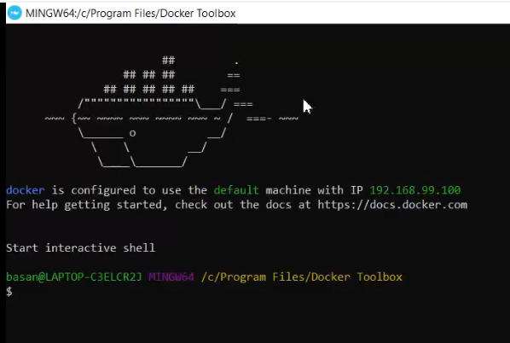

# How to push and pull Docker Image from Docker Hub?

First create your account in Docker Hub:

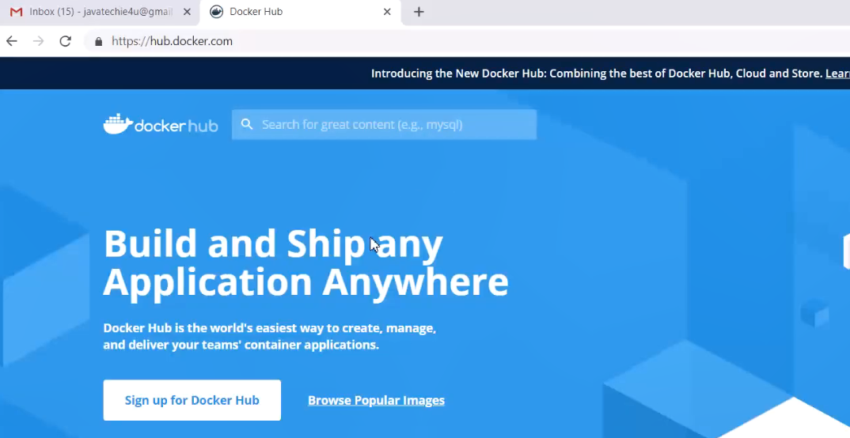

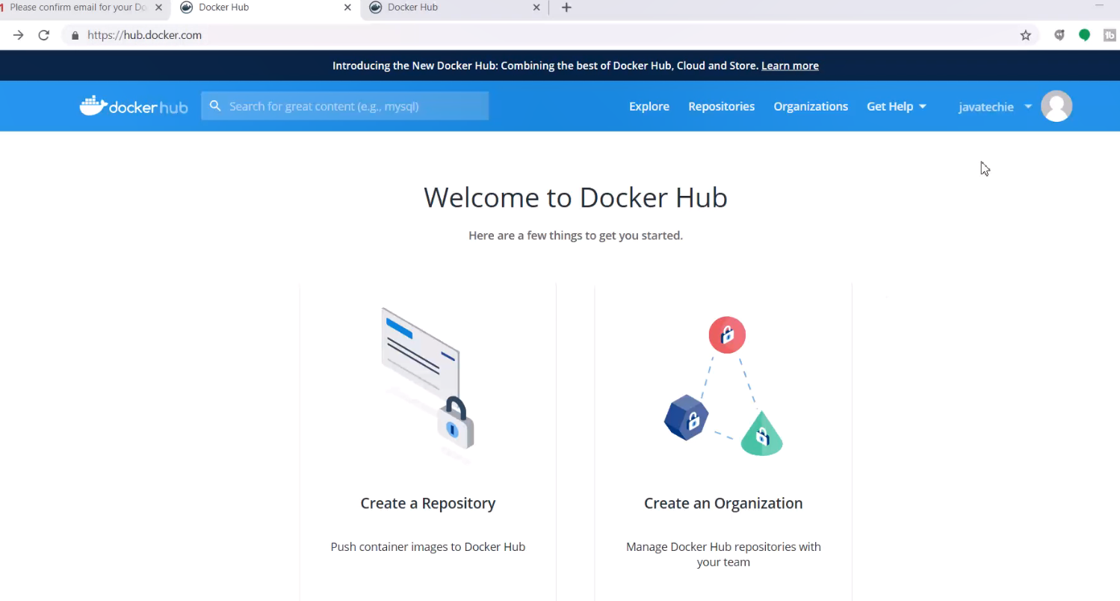

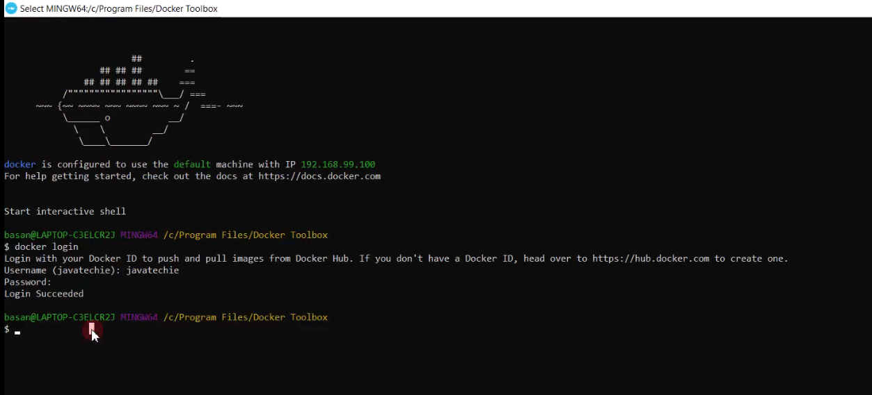

Login from docker toolbox.

Command:

docker login

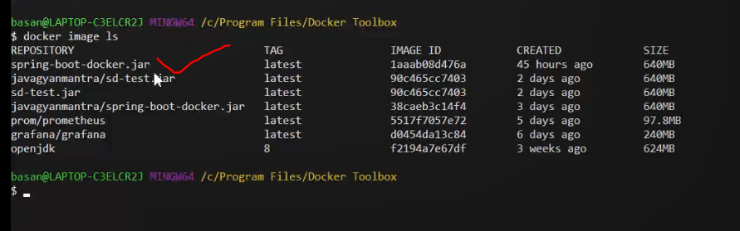

Note:

Docker Hub is a public repository. So, we need to specify some tags for our image.

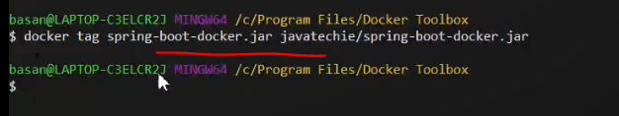

Tag command:

Docker tag <image name> <any tag name>/<image name>

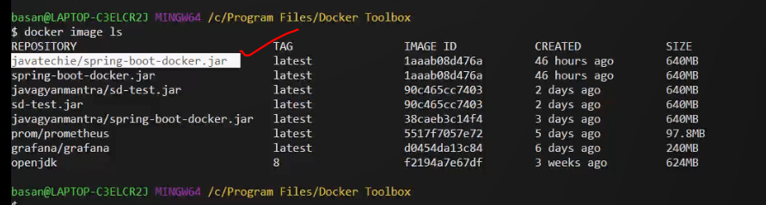

Now our tag is added.

Next, we have to push it to docker hub:

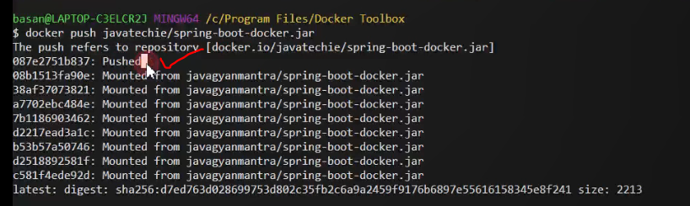

Command:

Docker push <tagname>/<imageName>

To verify:

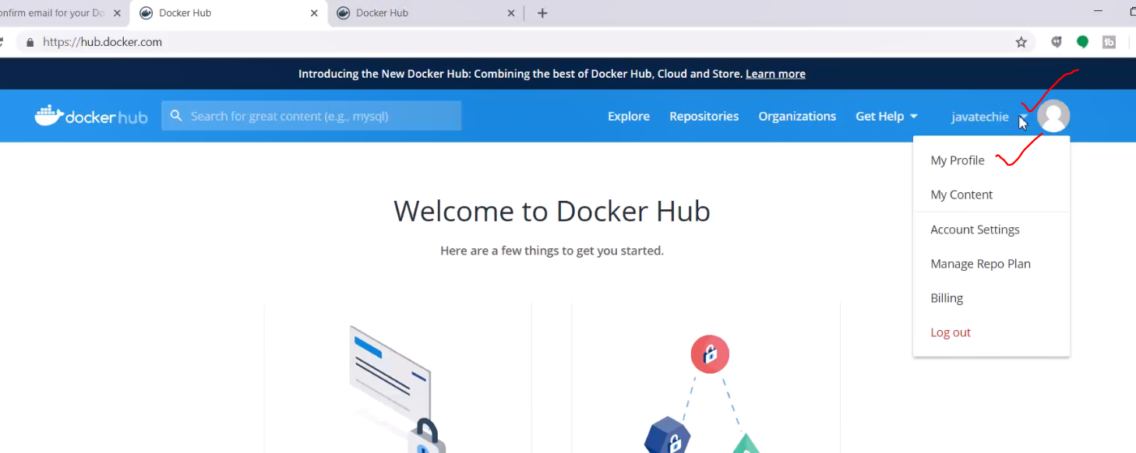

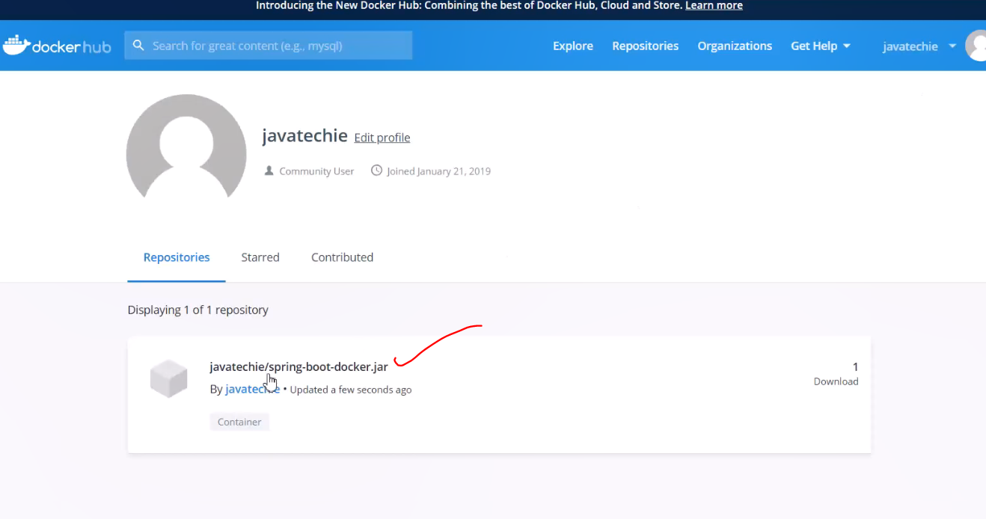

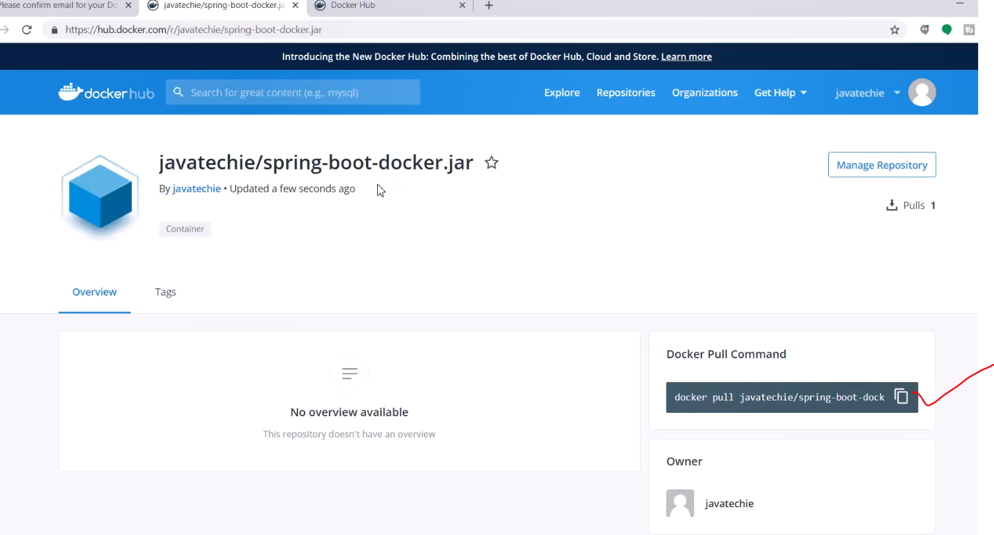

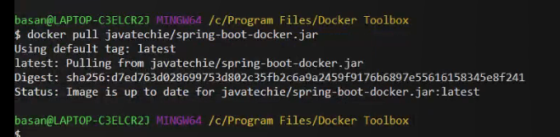

Then pull it so that it will be available in our local and we can run it.

Next we will run it:

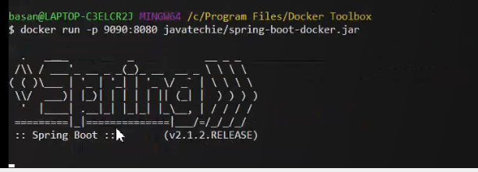

Command:

Docker run -p <port to run the image>:<the global post as mentioned in the image> <image name>

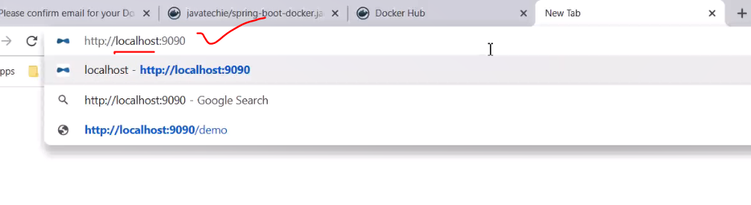

Replace localhost with our IP address.

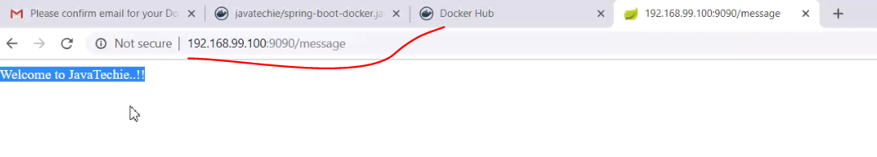

Done!